

**Snowflake Basics**

**Purpose:**

This document will be presented to the IAM team so that they can best assist new users that may need to gain access to Snowflake. This process will assume that the DBAs or System Admin has placed the users into the groups and the initial ticket request has been closed.

1. Log onto the Snowflake site: [Snowflake](https://ss53963.east-us-2.azure.snowflakecomputing.com/console/login#/)
2. Click on the “Sign in using PingFederate” button.
3. If you log in and your screen look like this: 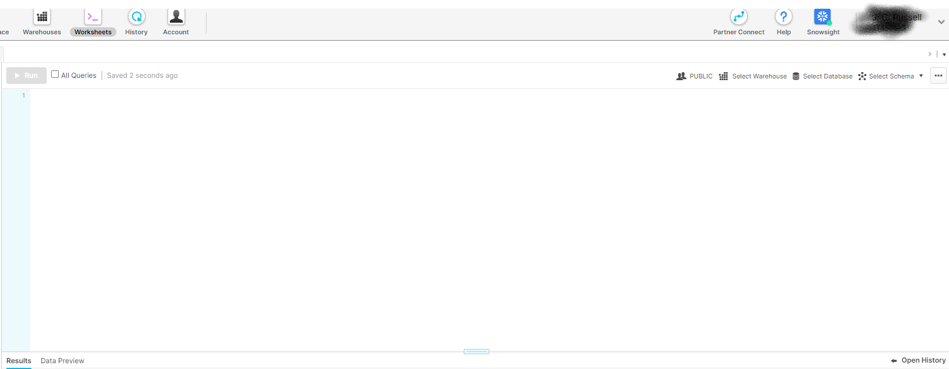

This is classic Snowflake (it has deprecated technology) most of the scripts and development work are completed in SnowSight to get there click on the icon that is circled (see image below). It may ask you to sign in again please do with the Pingfederate.

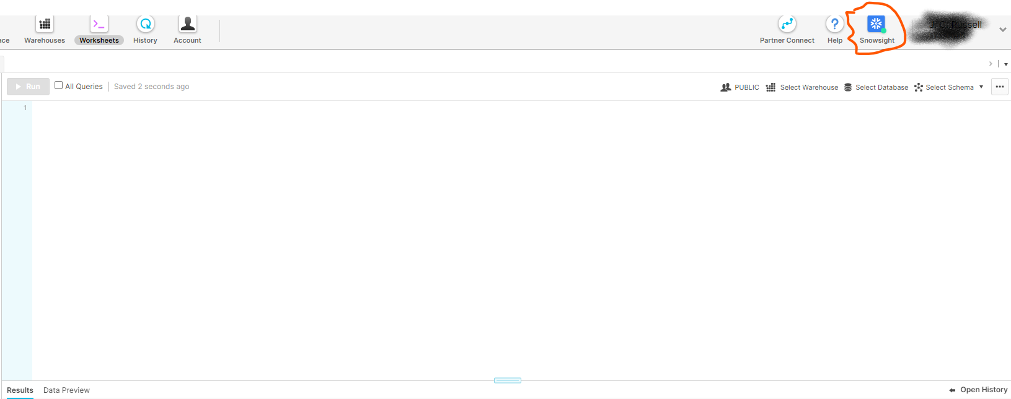

1. When you get into Snowflake you will see the layout like this.

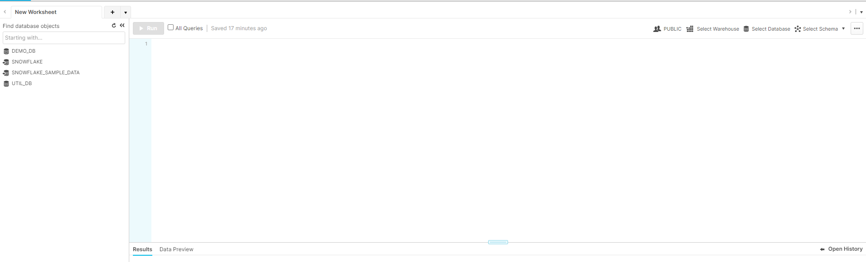

By default, it will have the user role (in red) and warehouse (in yellow)

